KINGSTON ENGINEERING COLLEGE-5113

ARTIFICIAL INTELLIGENCE - PHASE 4

TOPIC: PREDICTING HOUSE PRICES USING

MACHINE LEARNING

TEAM MEMBERS:

V. EBONICA SALETH-

au511321104025(ebonicasalethvincent@gm

ail.com)

G. KANIMOZHI- au511321104040(

kanimozhigopal2004@gmail.com)

D. AKSHAYA-

au511321104004(akshayadayalan03@gmail.

com)

K. INDUJA-

au511321104031(indujaindu137@gmail.com

)

CONTENT:

• PROBLEM STATEMENT

• PYTHON CODE WITH OUTPUT CREATED WITH GOOGLE

COLABORATORY

• CODE EXPLANATION:

1. IMPORTING LIBRARIES

2. LOADING THE GIVEN DATASET

3. DATA EXPLORATION

4. DATA VISUALIZATION

5. SPLITTING THE DATASET INTO FEATURES (X) AND TARGET VARIABLES(y)

6. PREPROCESSING THE DATASET USING MINMAX SCALER

7. FEATURE SELECTION (EXCLUDING THE ADDRESS (COLUMN)

8. SPLITTING THE DATASET INTO TRAINING AND TESTING SETS

9. PREPROCESSING THE DATASET USING STANDARD SCALER

10. CROSS-VALIDATION WITH DIFFERENT PREPROCESSING METHODS AND ALGORITHMS

11. BUILDING THE MODELS

• LINEAR REGRESSION MODEL

• RANDOM FOREST MODEL

• GRADIENT BOOSTING MODEL

• SUPPORT VECTOR REGRESSION MODEL

12. PERFORMANCE EVALUATION

13. CONCLUSION

LIBRARIES USED:

• PANDAS

• NUMPY

• SCI-KIT LEARN

• MATPLOTLIB

• SEABORN

DATASET DETAILS:

We will acquire our dataset from Kaggle, specifically the &quot;USA

Housing&quot; dataset. This dataset will contain a wealth of information

about houses in the USA, making it suitable for our predictive

modeling task.

• KAGGLE DATASET:

• LINK: https://www.kaggle.com/datasets/vedavyasv/usa-

housing

PROBLEM STATEMENT:

In this technology you will continue building your project by

selecting a machine learning algorithm, training the model,

and evaluating its performance. Perform different analysis as

needed. After performing the relevant activities create a

document around it and share the same for assessment.

PREDICTING HOUSE PRICES USING MACHINE

LEARNING

AI_Phase4(AKSHAYA D).ipynb

Original file is located at:

https://colab.research.google.com/drive/11An0zXsS5h0b_qorMMZh-4WOuaCOP74a?usp=sharing

PYTHON CODE WITH OUTPUT:

(FEATURE SELECTION, MODEL TRAINING AND

MODEL EVALUATION STEPS)

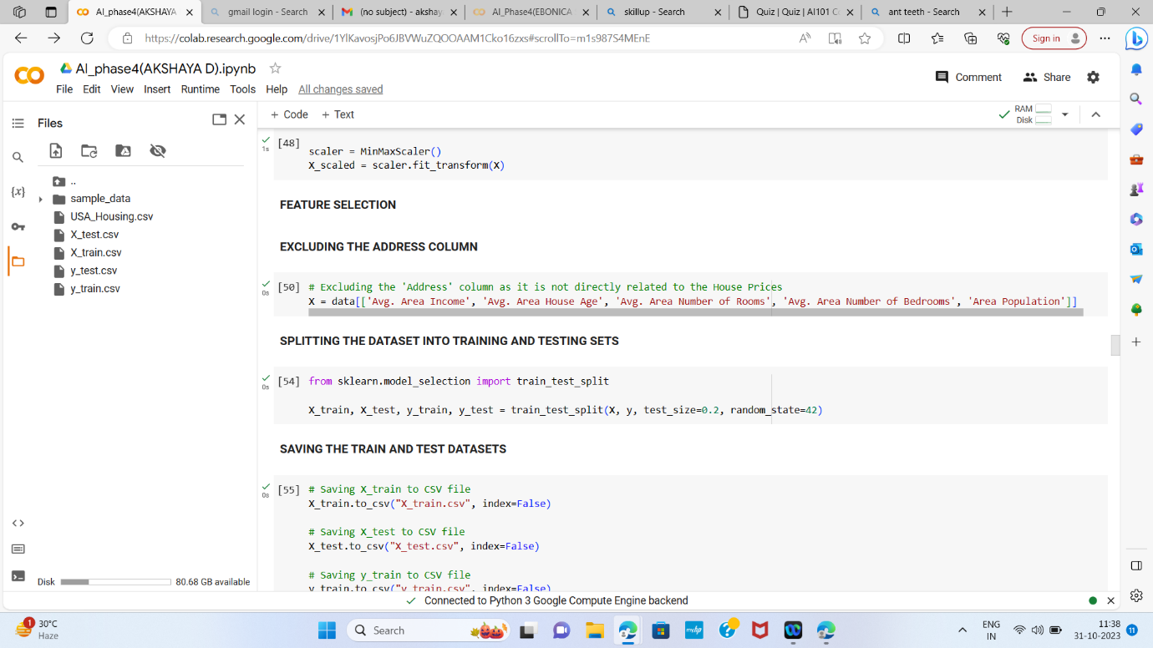

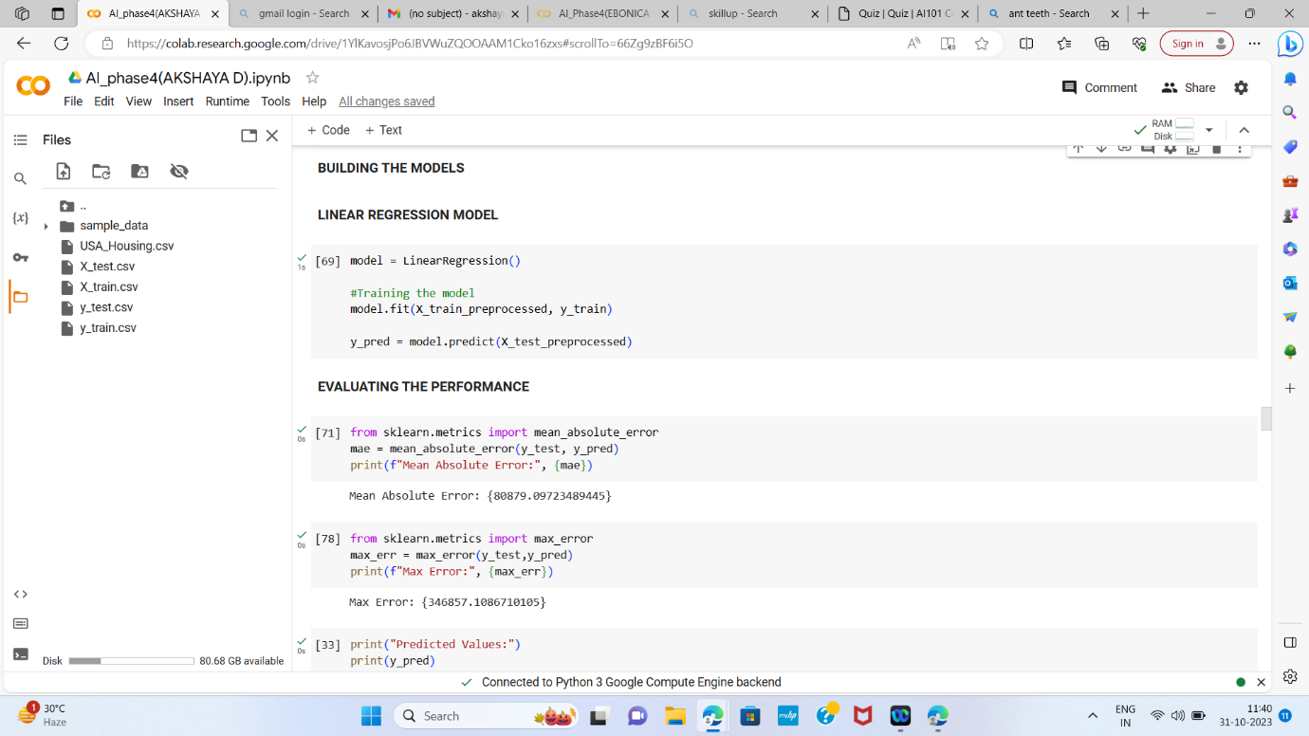

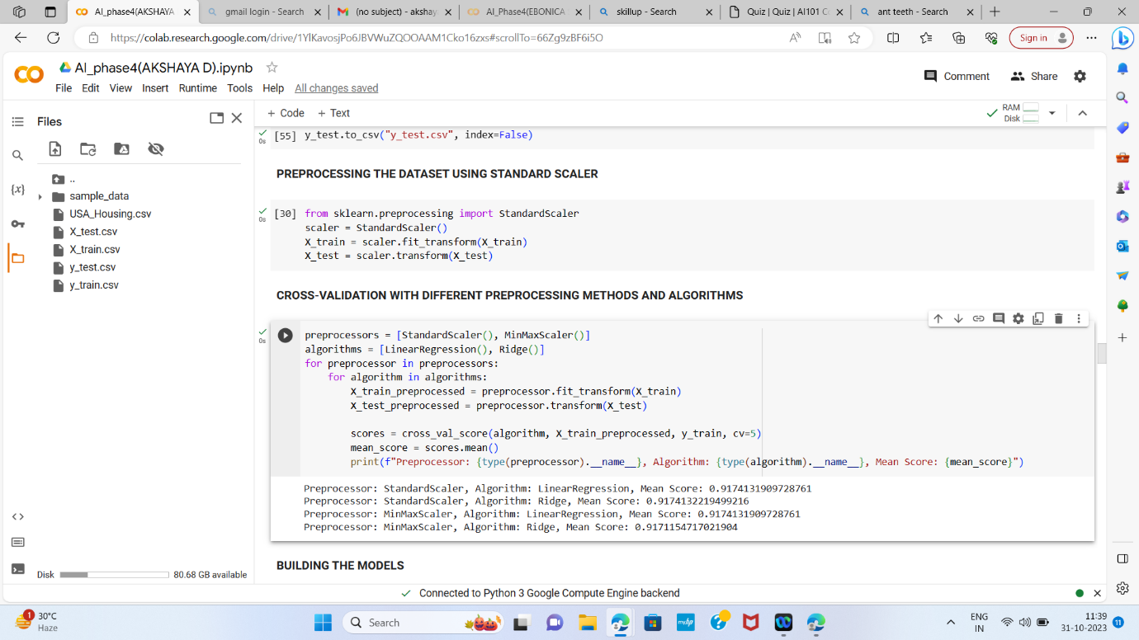



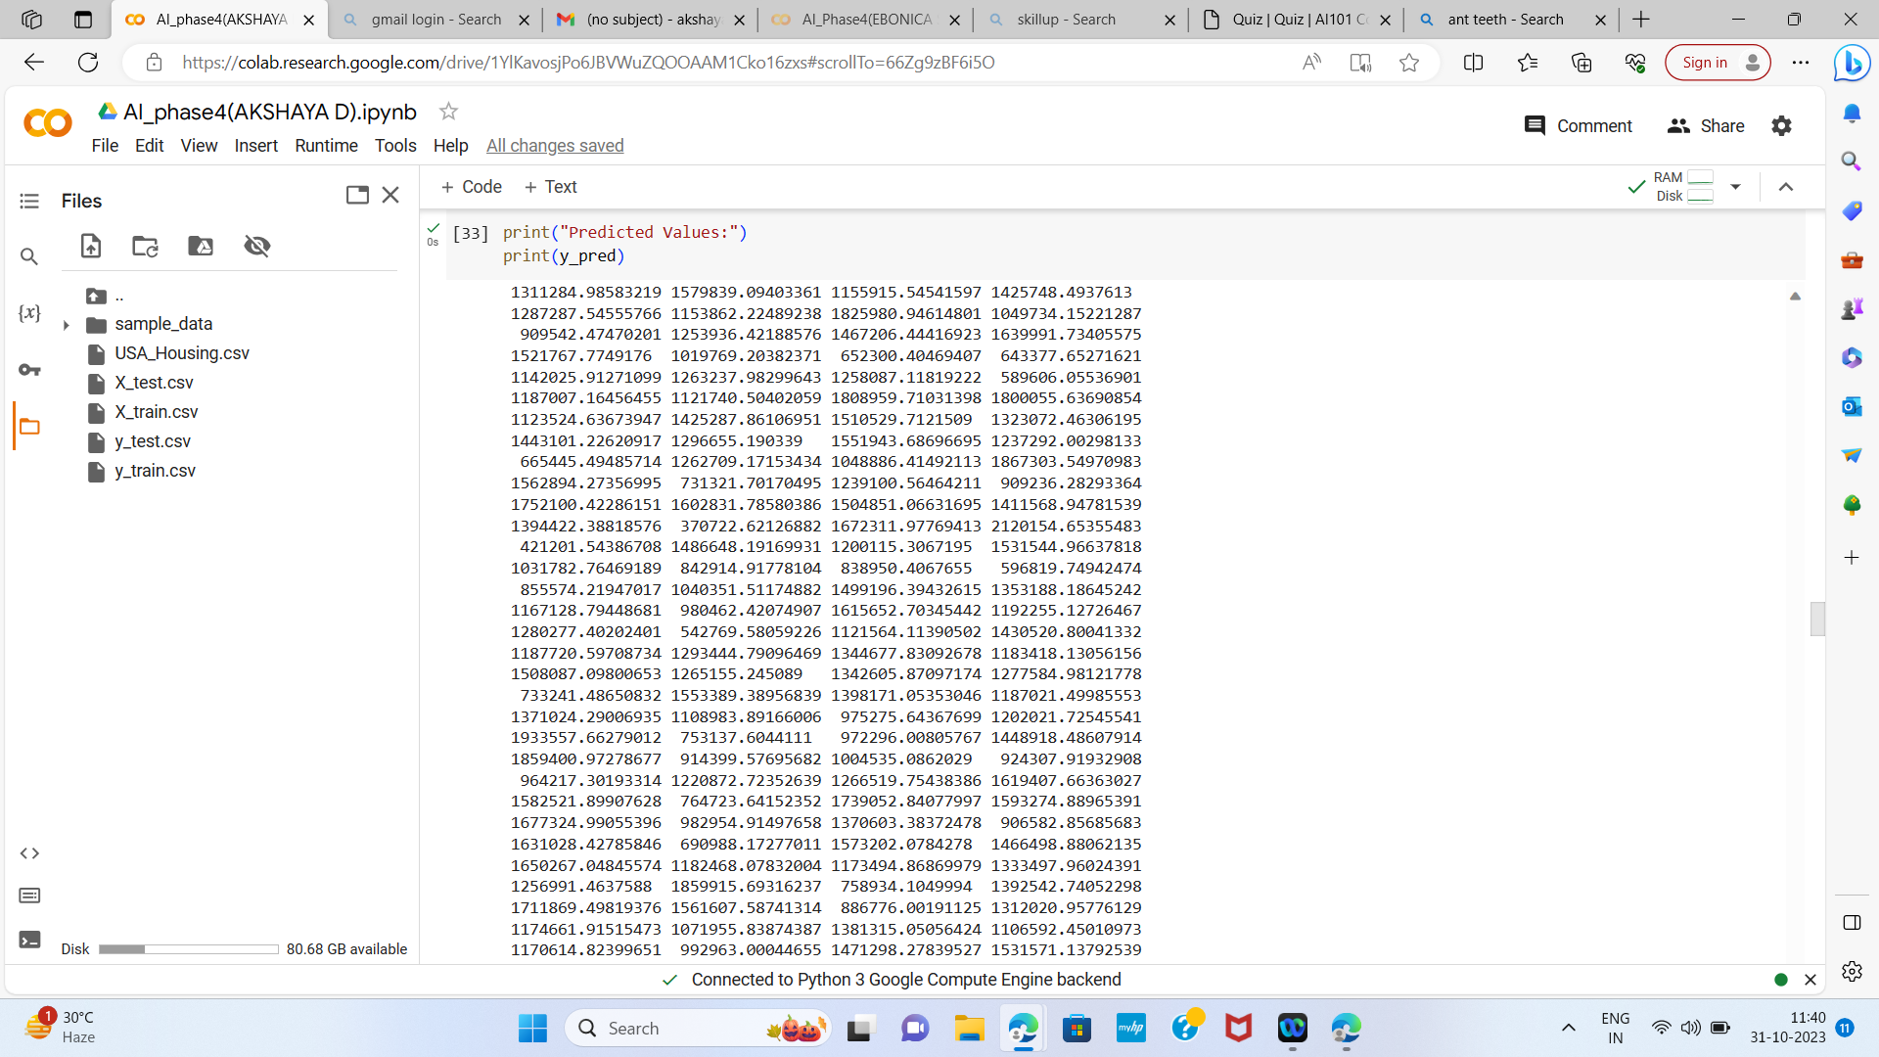

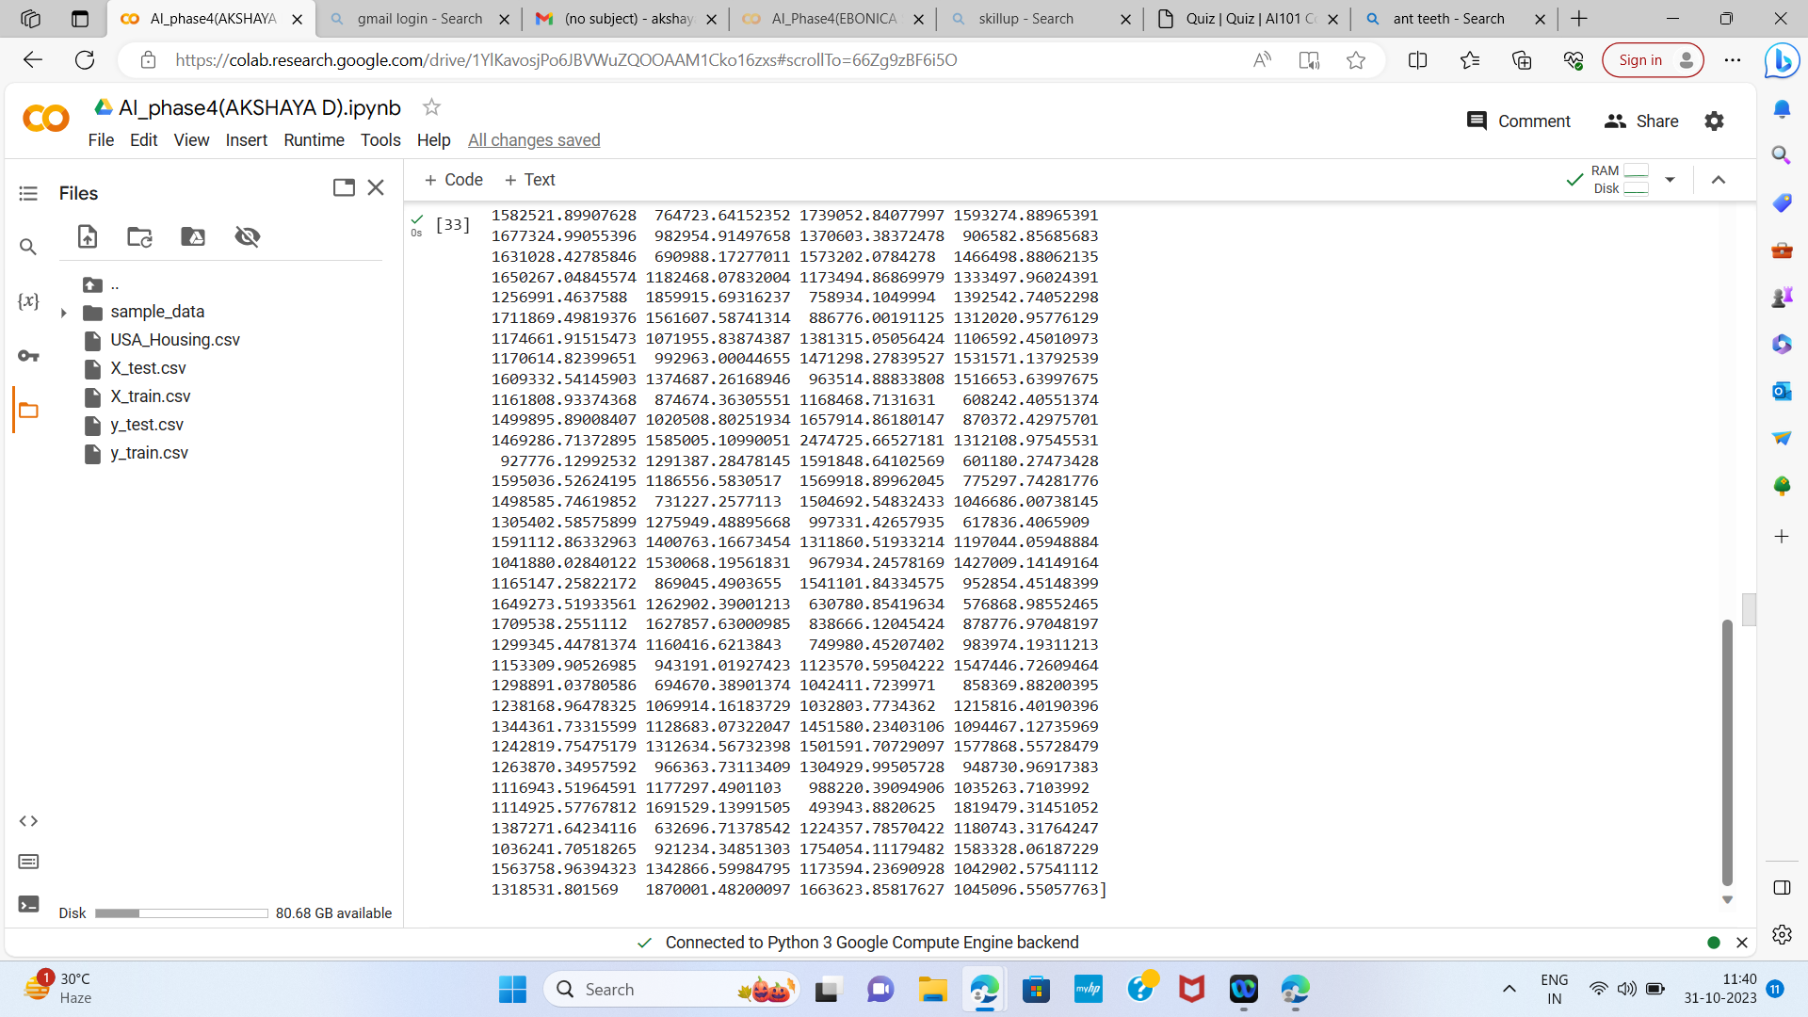

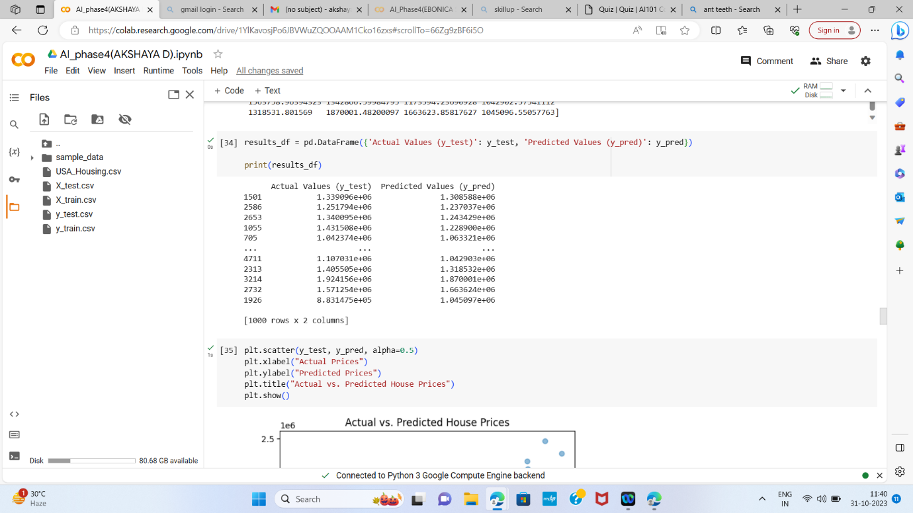

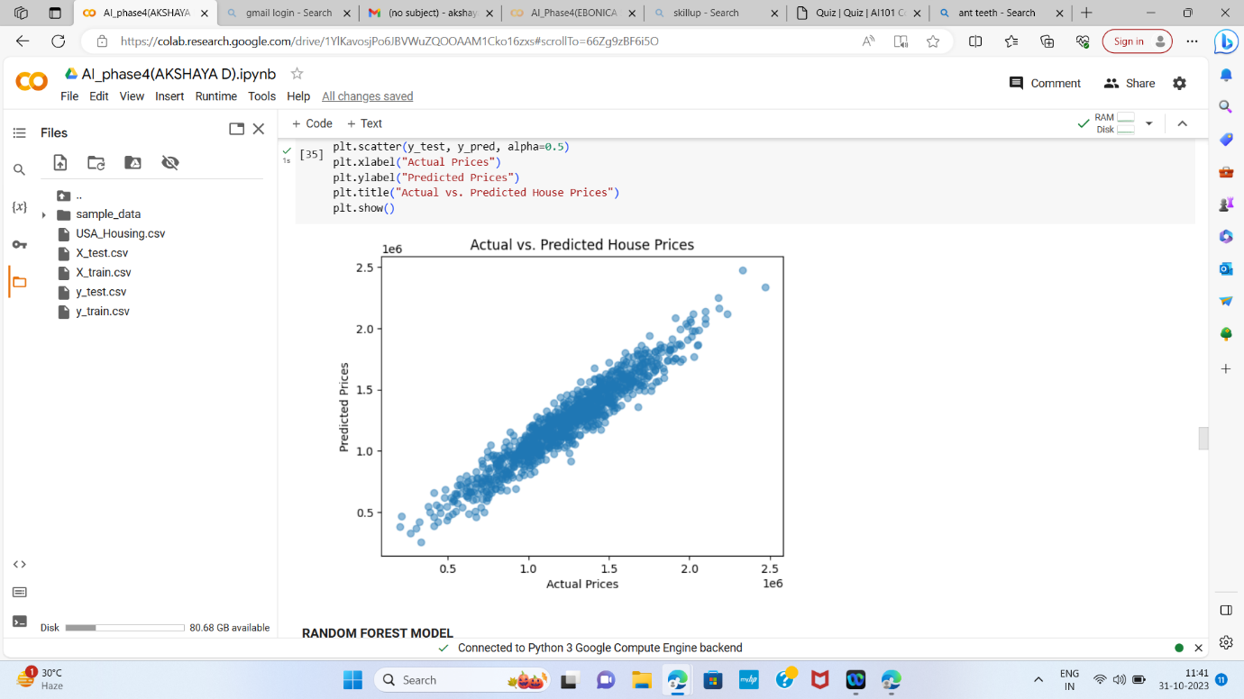

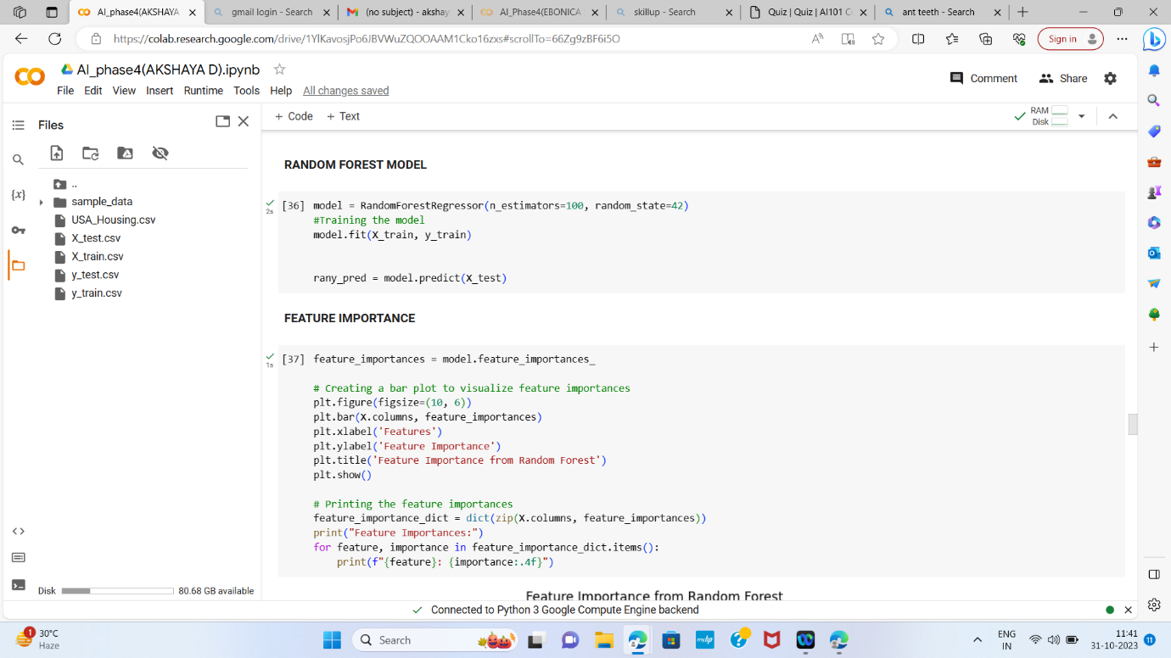

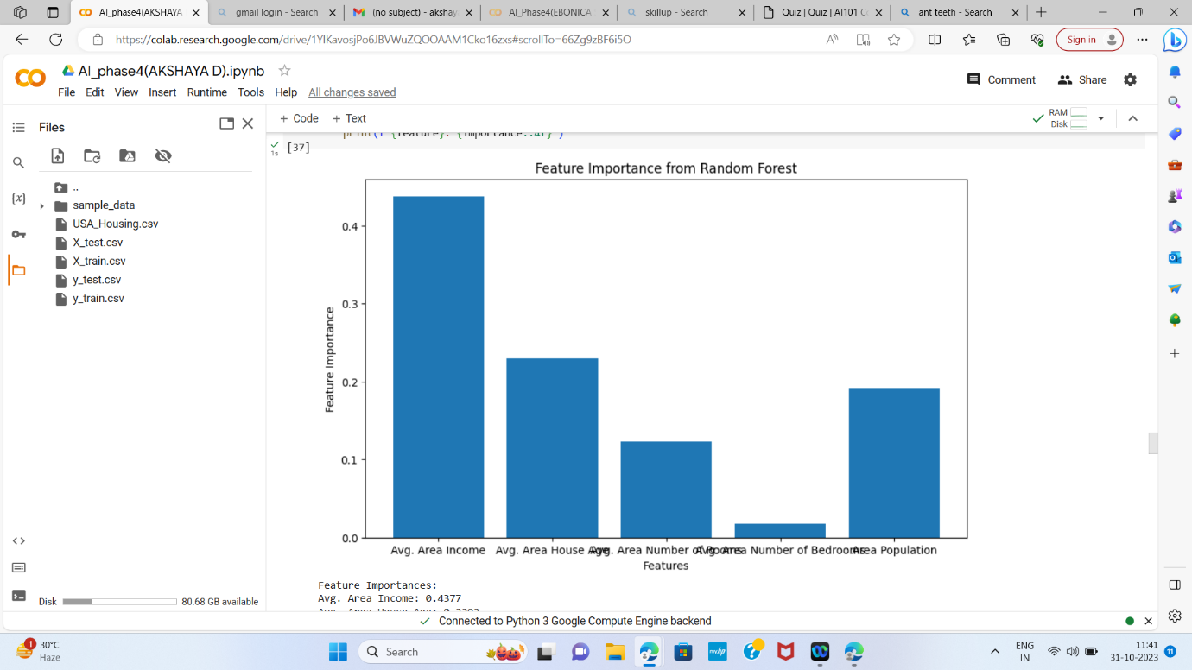

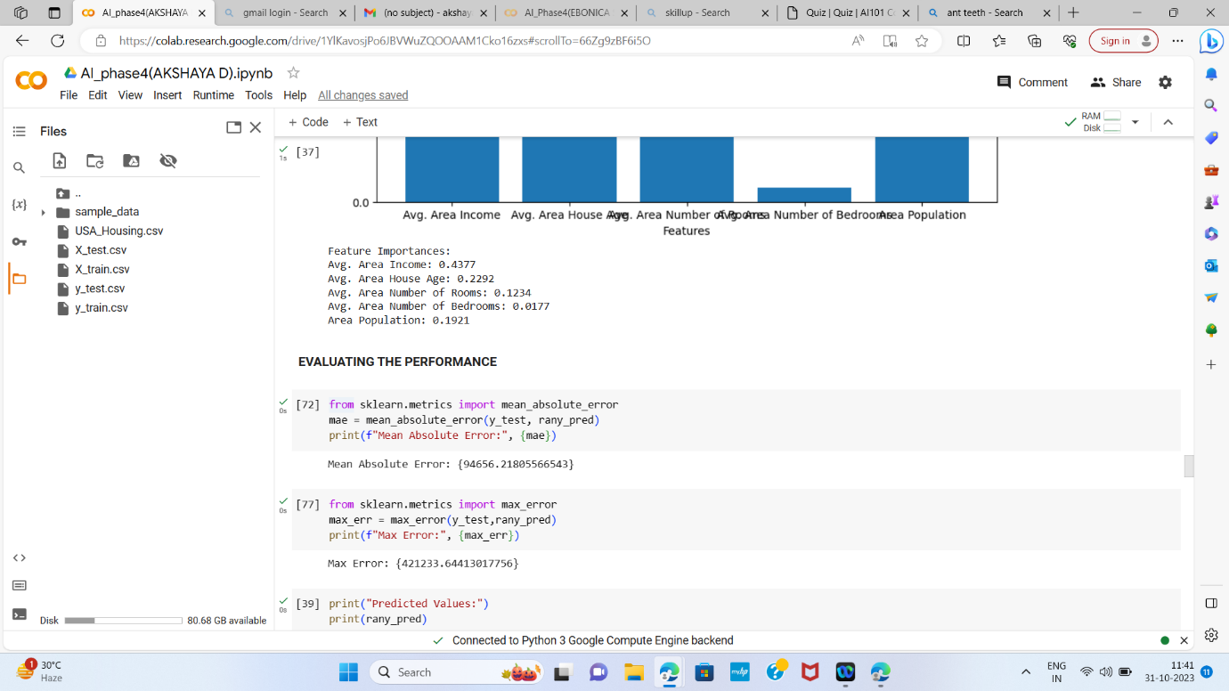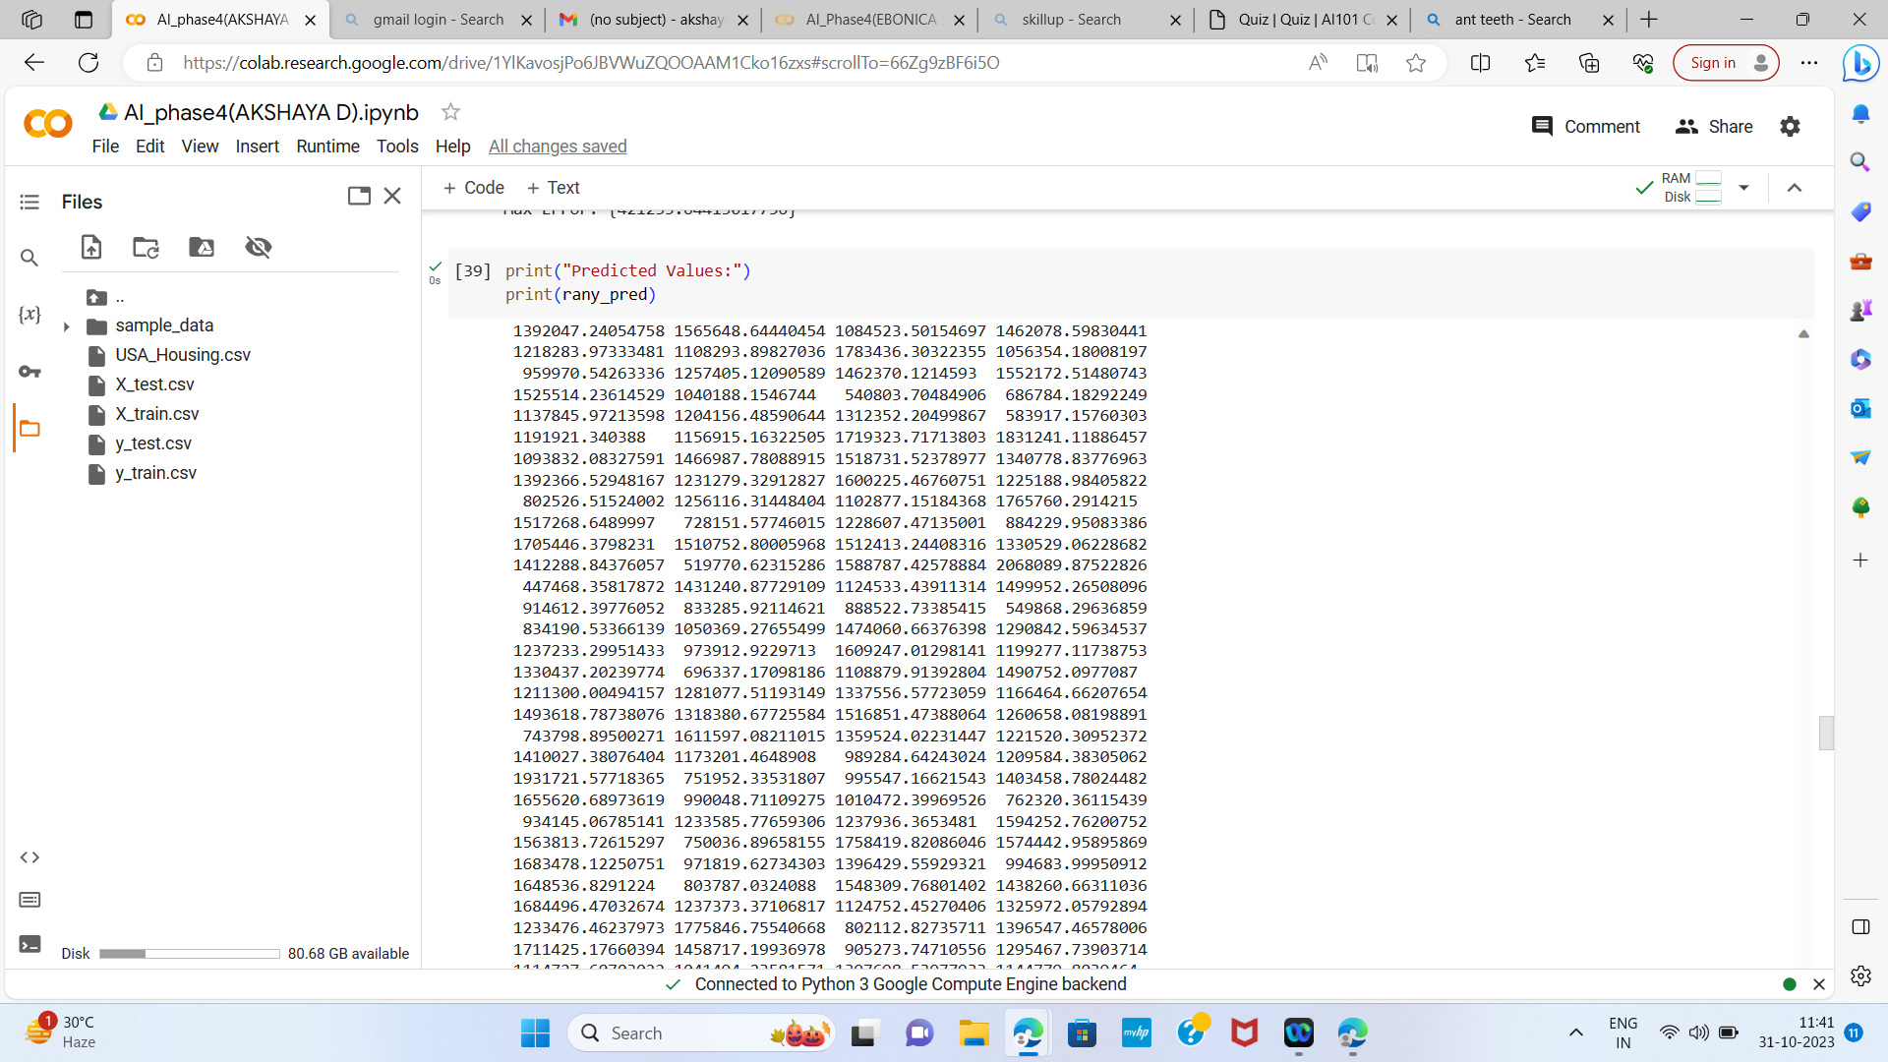



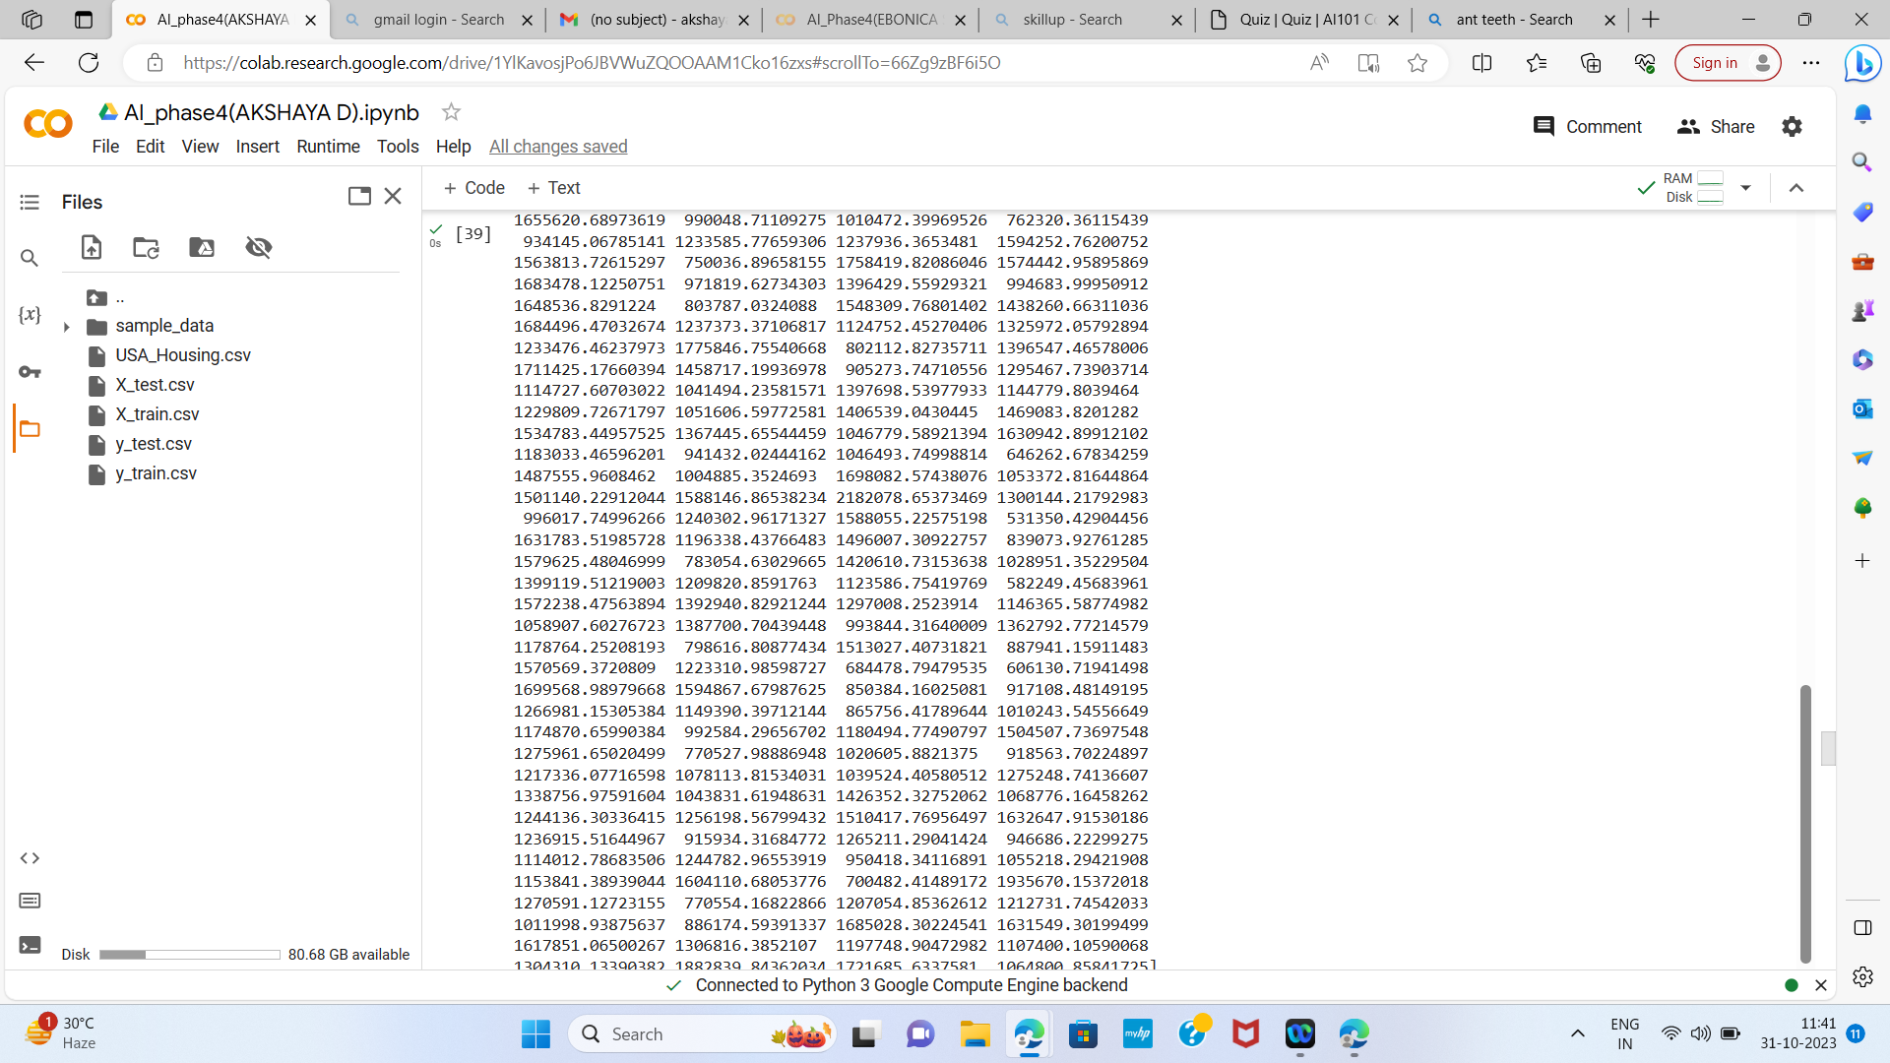



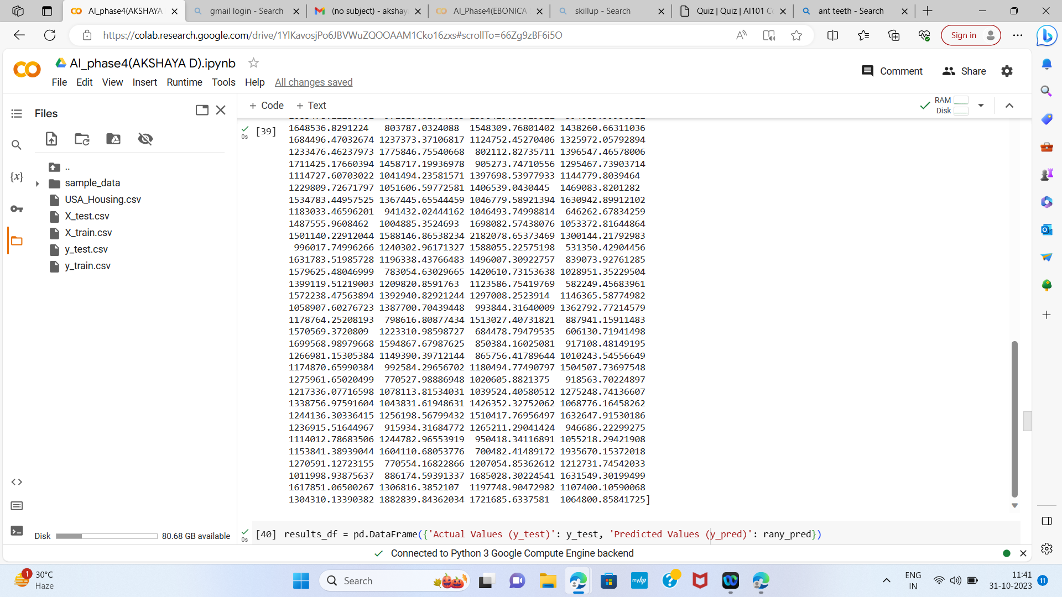

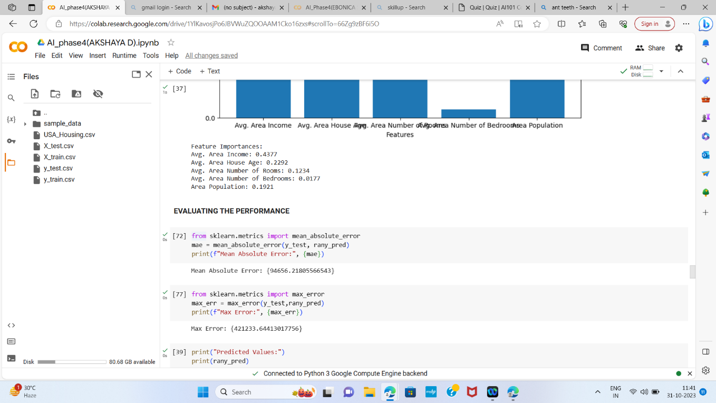

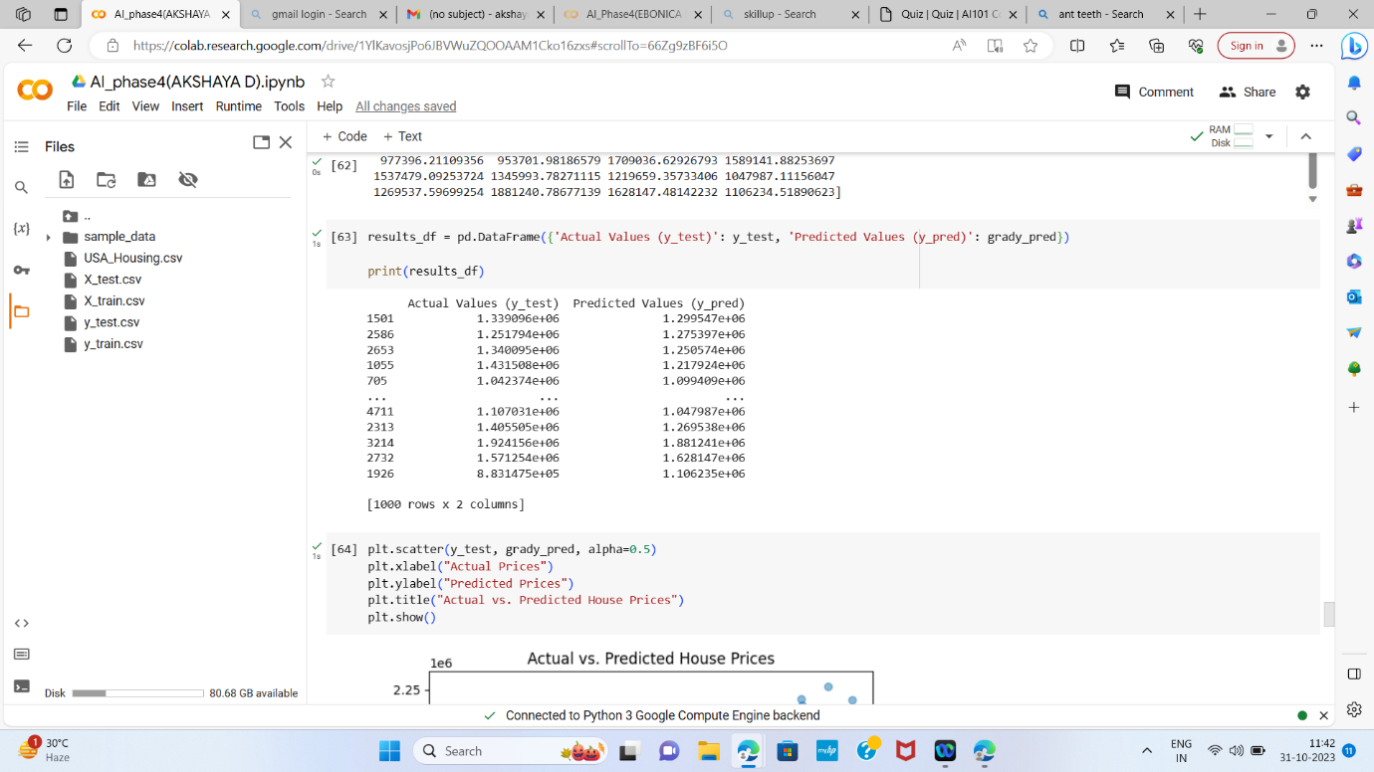

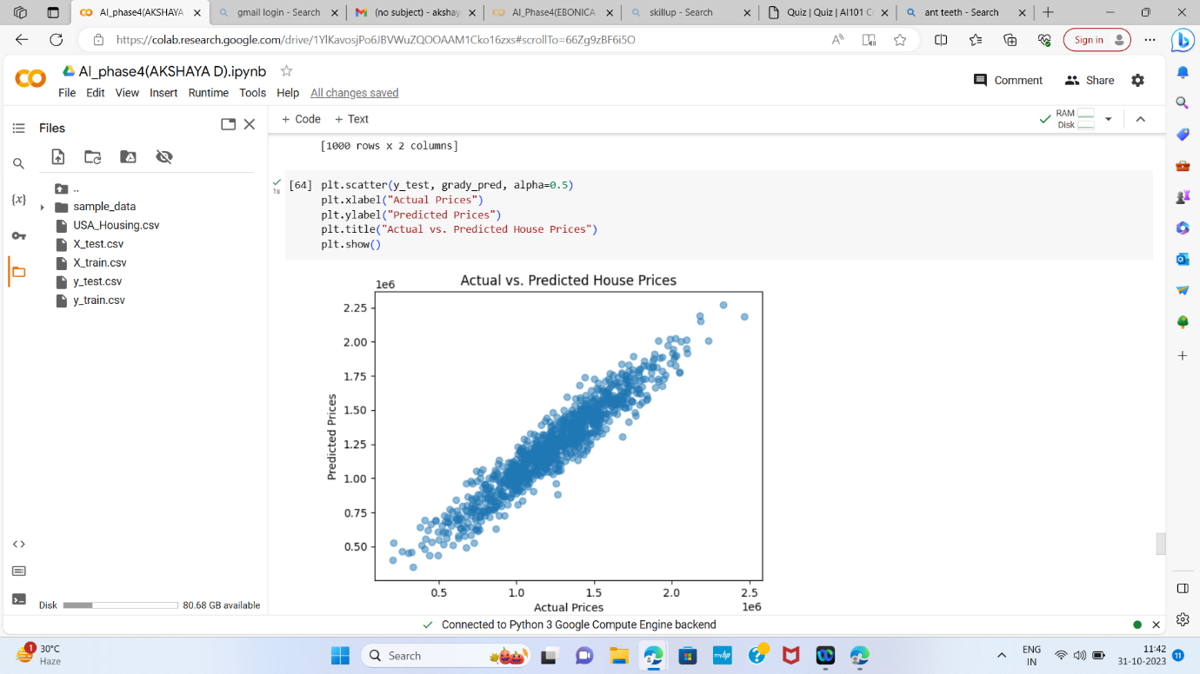

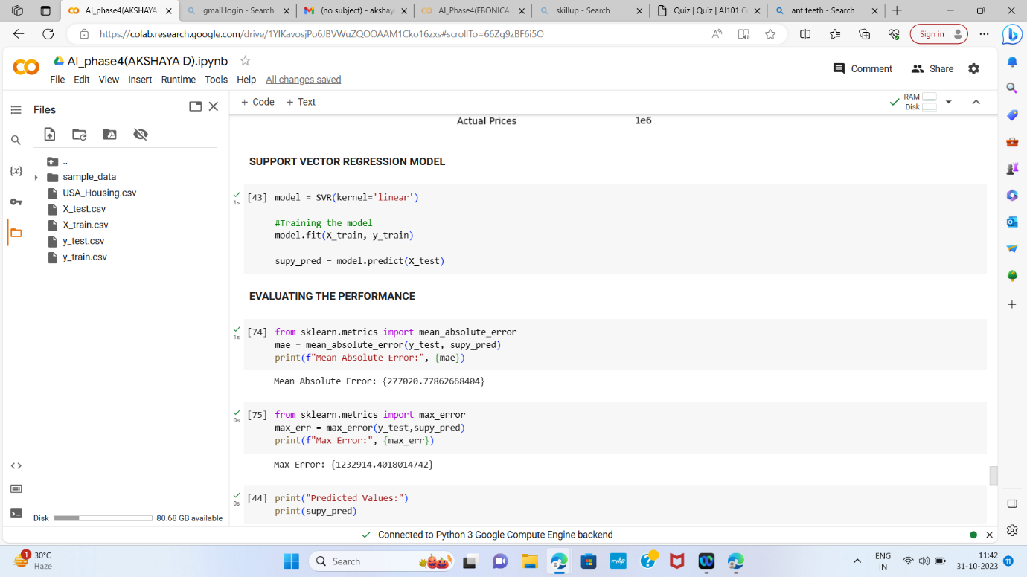

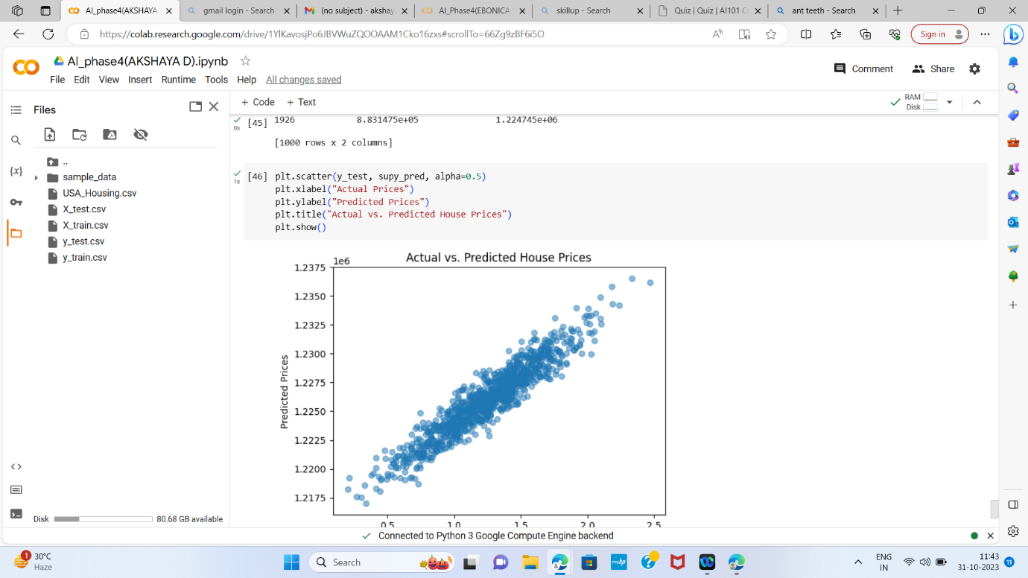

CODE EXPLANATION:

Introduction:

In this document, we will walk through the process of predicting

house prices using various machine learning techniques. This

comprehensive workflow involves data exploration, data

preprocessing, model training, and performance evaluation. The

primary objective is to create a model that can accurately predict

house prices based on a set of features.

1. Importing Libraries:

We begin by importing the necessary libraries and modules to

facilitate our analysis. These libraries include pandas for data

manipulation, scikit-learn for machine learning, numpy for numerical

operations, and matplotlib and seaborn for data visualization.

CODE:

import pandas as pd

from sklearn.model_selection import cross_val_score

from sklearn.linear_model import LinearRegression, Ridge

from sklearn.ensemble import RandomForestRegressor,

GradientBoostingRegressor

from sklearn.svm import SVR

from sklearn.metrics import mean_squared_error, r2_score

import numpy as np

import matplotlib.pyplot as plt

import seaborn as sns

2. Loading the Dataset:

We loaded the dataset named &quot;USA_Housing.csv&quot; into our working

environment(Google colab) using Google Colab. This dataset serves

as the foundation for our house price prediction analysis.

CODE:

from google.colab import files

uploaded = files.upload()

data = pd.read_csv(&quot;USA_Housing.csv&quot;)

3. Data Exploration:

In this phase, we conducted a thorough exploration of the dataset to

gain a better understanding of its structure and content.

CODE:

# Displays the first few rows of the dataset

print(&quot;First few rows of the dataset:&quot;)

print(data.head())

# Displays the last few rows of the dataset

print(&quot;Last few rows of the dataset:&quot;)

print(data.tail())

# Provides dataset information, including data types, non-null

values, and memory usage

print(&quot;Dataset Information:&quot;)

print(data.info())

# Calculates summary statistics to obtain a statistical overview of

the numerical variables

print(&quot;\nSummary statistics:&quot;)

print(data.describe())

# Identifies and addresses missing values within the dataset

print(&quot;\nMissing Values:&quot;)

print(data.isnull().sum())

# Lists the column names for reference

print(&quot;\nColumns:&quot;)

print(data.columns)

# Determines the shape of the dataset in terms of rows and

columns

print(&quot;\nShape:&quot;)

print(data.shape)

# Examines data types

print(&quot;\nDATA TYPES:&quot;)

print(data.dtypes)

# Accesses a specific row (index 20)

data.iloc[20]

# Calculates the number of unique values in each column

unique_counts = data.nunique()

print(&quot;Number of unique values in each column:&quot;)

print(unique_counts)

4. Data Visualization:

Data visualization is crucial for understanding the relationships

between variables and identifying patterns within the data. We

performed several data visualization tasks.

CODE:

# Creates a correlation heatmap to visualize relationships between

features

correlation_matrix = data.corr()

plt.figure(figsize=(10, 8))

sns.heatmap(correlation_matrix, annot=True, cmap=&quot;coolwarm&quot;)

plt.title(&quot;Correlation Heatmap&quot;)

plt.show()

# Constructs a histogram of house prices to understand their

distribution

plt.figure(figsize=(8, 6))

sns.histplot(data[&#39;Price&#39;], kde=True)

plt.xlabel(&quot;House Price&quot;)

plt ylabel(&quot;Frequency&quot;)

plt.title(&quot;Histogram of House Prices&quot;)

plt.show()

# Generates scatter plots to visualize the relationships between

house prices and specific features

# Scatter plot of Price vs. Avg. Area Income

sns.scatterplot(x=&#39;Avg. Area Income&#39;, y=&#39;Price&#39;, data=data)

plt.title(&quot;Price vs. Avg. Area Income&quot;)

plt.xlabel(&quot;Avg. Area Income&quot;)

plt.ylabel(&quot;Price&quot;)

plt.show()

# Scatter plot of Avg. Area House Age vs. Price

sns.scatterplot(x=&#39;Avg. Area House Age&#39;, y=&#39;Price&#39;, data=data)

plt.title(&quot;Price vs. Avg. Area House Age&quot;)

plt.xlabel(&quot;Avg. Area House Age&quot;)

plt.ylabel(&quot;Price&quot;)

plt.show()

# Scatter plot of Avg. Area Number of Rooms vs. Price

sns.scatterplot(x=&#39;Avg. Area Number of Rooms&#39;, y=&#39;Price&#39;, data=data)

plt.title(&quot;Price vs. Avg. Area Number of Rooms&quot;)

plt.xlabel(&quot;Avg. Area Number of Rooms&quot;)

plt.ylabel(&quot;Price&quot;)

plt.show()

# Scatter plot of Area Population vs. Price

sns.scatterplot(x=&#39;Area Population&#39;, y=&#39;Price&#39;, data=data)

plt.title(&quot;Price vs. Area Population&quot;)

plt.xlabel(&quot;Area Population&quot;)

plt.ylabel(&quot;Price&quot;)

plt.show()

5. Splitting the Dataset into Features and

Target Variable:

The dataset is divided into two main components:

Features (X): These are the predictor variables, such as Avg. Area

Income, Avg. Area House Age, Avg. Area Number of Rooms, Avg.

Area Number of Bedrooms and Area Population.

Target Variable (y): This represents the variable we aim to predict,

which is the &quot;Price&quot; of the houses.

CODE:

X = data[[&#39;Avg. Area Income&#39;, &#39;Avg. Area House Age&#39;, &#39;Avg. Area

Number of Rooms&#39;, &#39;Avg. Area Number of Bedrooms&#39;, &#39;Area

Population&#39;]]

y = data[&#39;Price&#39;]

6. Preprocessing the Dataset Using MinMax

Scaler:

We preprocessed the features using MinMaxScaler to standardize

the feature values.

CODE:

from sklearn.preprocessing import MinMaxScaler

scaler = MinMaxScaler()

X_scaled = scaler.fit_transform(X)

7. Feature Selection:

We excluded the &quot;Address&quot; column from the features, as it is not

directly related to the prediction of house prices.

CODE:

# Excluding the &#39;Address&#39; column as it is not directly related to the

House Prices

X = data[[&#39;Avg. Area Income&#39;, &#39;Avg. Area House Age&#39;, &#39;Avg. Area

Number of Rooms&#39;, &#39;Avg. Area Number of Bedrooms&#39;, &#39;Area

Population&#39;]]

8. Splitting the Dataset into Training and

Testing Sets:

To assess the model&#39;s performance, we divided the dataset into

training and testing sets with an 80/20 split. This allows us to train

the model on one portion of the data and evaluate its performance

on another, unseen portion.

CODE:

from sklearn.model_selection import train_test_split

X_train, X_test, y_train, y_test = train_test_split(X, y, test_size=0.2,

random_state=42)

9. Preprocessing the Dataset Using Standard

Scaler:

In addition to MinMaxScaler, we also applied StandardScaler to

preprocess the features. This further standardizes the data for

MODELING

CODE:

from sklearn.preprocessing import StandardScaler

scaler = StandardScaler()

X_train = scaler.fit_transform(X_train)

X_test = scaler.transform(X_test)

10. Cross-Validation with Different

Preprocessing Methods and Algorithms:

To determine the effectiveness of different preprocessing methods

and machine learning algorithms, we performed cross-validation.

The methods tested include StandardScaler and MinMaxScaler, and

the algorithms tested are Linear Regression and Ridge Regression.

Mean scores are calculated to evaluate each combination&#39;s

performance.

CODE:

preprocessors = [StandardScaler(), MinMaxScaler()]

algorithms = [LinearRegression(), Ridge()]

for preprocessor in preprocessors:

for algorithm in algorithms:

X_train_preprocessed = preprocessor.fit_transform(X_train)

X_test_preprocessed = preprocessor.transform(X_test)

scores = cross_val_score(algorithm, X_train_preprocessed, y_train,

cv=5)

mean_score = scores.mean()

print(f&quot;Preprocessor: {type(preprocessor).__name__},

Algorithm: {type(algorithm).__name__}, Mean Score: {mean_score}&quot;)

11. Building the Models:

Linear Regression Model:

We trained a Linear Regression model using the preprocessed

training data. This model is commonly used for regression tasks.

CODE:

model = LinearRegression()

# Training the model

model.fit(X_train_preprocessed, y_train)

y_pred = model.predict(X_test_preprocessed)

Random Forest Model:

A Random Forest Regressor, a powerful ensemble model, is trained

and evaluated. Feature importance is calculated to understand which

features have the most significant impact on the predictions.

CODE:

model = RandomForestRegressor(n_estimators=100,

random_state=42)

# Training the model

model.fit(X_train, y_train)

rany_pred = model.predict(X_test)

Gradient Boosting Model:

el:We also trained and evaluated a Gradient Boosting Regressor,

another ensemble method known for its predictive power.

CODE:

model=GradientBoostingRegressor(n_estimators=100,random_state

=42)

# Training the model

model.fit(X_train, y_train)

grady_pred = model.predict(X_test)

Support Vector Regression Model:

We applied Support Vector Regression (SVR) with a linear kernel to

the dataset and evaluated its performance.

CODE:

model = SVR(kernel=&#39;linear&#39;)

# Training the model

model.fit(X_train, y_train)

supy_pred = model.predict(X_test)

12. Performance Evaluation:

For each model, we calculated two key metrics:

Mean Squared Error (MSE): This metric quantifies the average

squared difference between predicted and actual values.

R-squared (R2) Score: R2 measures the proportion of the variance in

the target variable that can be explained by the model.

We also created scatter plots to visualize the relationship between

actual and predicted house prices, providing an intuitive view of

model performance.

CODE:

# Linear Regression Performance Evaluation

mse = mean_squared_error(y_test, y_pred)

r2 = r2_score(y_test, y_pred)

print(&quot;Linear Regression - Mean Squared Error:&quot;, mse)

print(&quot;Linear Regression - R-squared (R2) Score:&quot;, r2)

results_df = pd.DataFrame({&#39;Actual Values (y_test)&#39;: y_test,

&#39;Predicted Values (y_pred)&#39;: y_pred})

print(results_df)

plt.scatter(y_test, y_pred, alpha=0.5)

plt.xlabel(&quot;Actual Prices&quot;)

plt.ylabel(&quot;Predicted Prices&quot;)

plt.title(&quot;Actual vs. Predicted House Prices&quot;)

plt.show()

# Random Forest Performance Evaluation

mse = mean_squared_error(y_test, rany_pred)

r2 = r2_score(y_test, rany_pred)

print(&quot;Random Forest - Mean Squared Error:&quot;, mse)

print(&quot;Random Forest - R-squared (R2) Score:&quot;, r2)

results_df = pd.DataFrame({&#39;Actual Values (y_test)&#39;: y_test,

&#39;Predicted Values (y_pred)&#39;: rany_pred})

print(results_df)

plt.scatter(y_test, rany_pred, alpha=0.5)

plt.xlabel(&quot;Actual Prices&quot;)

plt.ylabel(&quot;Predicted Prices&quot;)

plt.title(&quot;Actual vs. Predicted House Prices&quot;)

plt.show()

# Gradient Boosting Performance Evaluation

mse = mean_squared_error(y_test, grady_pred)

r2 = r2_score(y_test, grady_pred)

print(&quot;Gradient Boosting - Mean Squared Error:&quot;, mse)

print(&quot;Gradient Boosting - R-squared (R2) Score:&quot;, r2)

results_df = pd.DataFrame({&#39;Actual Values (y_test)&#39;: y_test,

&#39;Predicted Values (y_pred)&#39;: grady_pred})

print(results_df)

plt.scatter(y_test, grady_pred, alpha=0.5)

plt.xlabel(&quot;Actual Prices&quot;)

plt.ylabel(&quot;Predicted Prices&quot;)

plt.title(&quot;Actual vs. Predicted House Prices&quot;)

plt.show()

# Support Vector Regression Performance Evaluation

mse = mean_squared_error(y_test, supy_pred)

r2 = r2_score(y_test, supy_pred)

print(&quot;SVR - Mean Squared Error:&quot;, mse)

print(&quot;SVR - R-squared (R2) Score:&quot;, r2)

results_df = pd.DataFrame({&#39;Actual Values (y_test)&#39;: y_test,

&#39;Predicted Values (y_pred)&#39;: supy_pred})

print(results_df)

plt.scatter(y_test, supy_pred, alpha=0.5)

plt.xlabel(&quot;Actual Prices&quot;)

plt.ylabel(&quot;Predicted Prices&quot;)

plt.title(&quot;Actual vs. Predicted House Prices&quot;)

plt.show()

We built and evaluated various machine learning models, including Linear Regression, Random Forest, Gradient Boosting, and Support Vector Regression (SVR). For each model, we trained it on the training data and made predictions on the test data. We evaluated the model's performance using metrics such as Max Error and Mean Absolute Error (MAE).

**Max error:**The max_error function in scikit-learn is a metric used for evaluating the performance of regression models. It calculates the maximum residual error between the true target values and the predicted values. The residual error is the absolute difference between the actual and predicted values, and the max_error function identifies the largest such difference.

MEAN ABSOLUTE ERROR

·            Mean Absolute Error (MAE), also known as the Mean Absolute Deviation (MAD), is a common metric used in statistics and machine learning to measure the average absolute difference between the observed (actual) values and the predicted values in a dataset. Like Mean Squared Error (MSE) and Root Mean Squared Error (RMSE), MAE is used to evaluate the performance of regression models.

·      The formula for calculating Mean Absolute Error is:

                          MAE = (1/n) * Σ|yi - ŷi|

Conclusion:

In conclusion, this document outlines the entire process of predicting

house prices using machine learning, from data exploration to model

building and evaluation. The results obtained from different models

and preprocessing techniques can guide decisions on selecting the

most suitable approach for accurately predicting house prices.